Group Member Details
Katlego Sentsho u24876489
Patrick Simuyemba u25632354
Enock Nyamweya u25619871
Angelo Anthony u25573552
Ntando Dlamini u25591267
Angela Ramaboea u25445392

Task 1: Research Findings on Workflow Management Systems
What a WfMS is. The Workflow Management Coalition (WfMC) defines workflow as the computerised automation of a business process and a workflow management system (WfMS) as software that defines, manages and executes workflows, with execution order driven by a computer representation of the process logic [1]. All WfMSs share three areas: build-time definition, run-time process control, and run-time interaction with people and applications [1].
Definition vs instance. A process definition holds the activities, transition conditions, roles, workflow-relevant data, invoked applications and a version number. An engine interprets it to create and control many independent instances (“cases”) [1][2]. The instance owns control data (the state of each process and activity instance), case data used for routing decisions, and its audit trail [1]. Because processes can run for weeks, engines such as Camunda let running instances finish on the version they started with, send new instances to the latest version, and offer optional migration [5]. A change to a definition therefore never silently changes work already in progress.
Work items and nesting. Activities are either atomic or compound (sub-flows) [1][2]. The WfMC describes hierarchical nesting, where a whole process is enacted as one activity of a parent process [1], and BPMN models the same idea with embedded sub-processes and reusable call activities [4]. Control-flow constructs that recur across products are sequence, parallel split and synchronisation, exclusive choice and merge, loops and cancellation; none of the 15 products compared in [2] supported every pattern, so the set of routing constructs must be extensible.
Assignment, approval and escalation. Definitions refer to roles rather than named people, and the engine binds roles to participants at run time [1]. The resource patterns catalogue [3] separates push allocation (system chooses) from pull allocation (participant claims), and lists allocation rules such as random, round-robin and shortest-queue, plus delegation and escalation. Approvals are modelled as work items whose outcome feeds routing conditions, and BPMN adds timer, escalation and error events for deadlines and failures [4].
Events, failures and history. The WfMC treats the engine as a state machine in which process and activity instances move between states (e.g. initiated, running, suspended, completed, terminated) in response to events and control decisions, with checkpoint and recovery data kept for failure handling [1]. Audit trails, metrics and supervisory operations are exposed through an administration and monitoring interface [1].
External systems. Engines do not hard-code applications. They invoke them through an invoked-application interface or application agents, and reach other engines through gateways that map names and data [1].
Reusability and configurability. Workflow separates procedure logic from IT support [1], so a generic engine interprets definitions instead of embedding a process. Routing conditions, role binding, allocation rules, escalation rules, invoked applications and versions are all definition data, not engine code [1][3][5].
Findings that drive the TIVIDY design
Recurring responsibility | Expected to vary | Design consequence
Definition vs instance, versioning | The process blueprint; running cases | Definition built step by step (Builder); each instance owns its state, data and history (State, Memento)
Nested, parallel work | Shape and depth of the process | Uniform work-item tree (Composite)
Allocation, approval, escalation | Allocation rule; approval levels | Strategy; Chain of Responsibility
Events, audit, undo, extra behaviour | Who reacts; what is reversible | Observer; Command; Memento; Decorator
External systems, participants | Foreign APIs; who talks to whom | Adapter; Mediator; single entry point (Facade)
References
[1] Hollingsworth, D. (1995). The Workflow Reference Model (WfMC Document TC00-1003, Issue 1.1). Workflow Management Coalition. https://www.aiai.ed.ac.uk/project/wfmc/ARCHIVE/DOCS/refmodel/rmv1-16.html
[2] van der Aalst, W.M.P., ter Hofstede, A.H.M., Kiepuszewski, B., & Barros, A.P. (2003). Workflow Patterns. Distributed and Parallel Databases, 14(1), 5–51. https://doi.org/10.1023/A:1022883727209 (open copy: pure.tue.nl)
[3] Russell, N., van der Aalst, W.M.P., ter Hofstede, A.H.M., & Edmond, D. (2005). Workflow Resource Patterns: Identification, Representation and Tool Support. In CAiSE 2005, LNCS 3520, pp. 216–232. Springer. https://doi.org/10.1007/11431855_16
[4] Object Management Group. (2011). Business Process Model and Notation (BPMN), Version 2.0 (formal/2011-01-03). https://www.omg.org/spec/BPMN/2.0
[5] Camunda. (n.d.). Versioning process definitions (Best practices). Accessed 3 October 2026. https://docs.camunda.io/docs/components/best-practices/operations/versioning-process-definitions/
[6] Gamma, E., Helm, R., Johnson, R., & Vlissides, J. (1994). Design Patterns: Elements of Reusable Object-Oriented Software. Addison-Wesley. ISBN 978-0-201-63361-0.

Task 2: Define the Scenario and System
2.1 Selected Scenario: Faculty Admissions and Bursary Processing
To demonstrate and validate the generic TIVIDY engine, the system is applied to an Admissions and Bursary Processing workflow. This administrative process models an end-to-end lifecycle characterized by high-volume applications, strict academic validation rules, multi-tier financial approvals, parallel departmental coordination, and external system integrations.

The process consists of six sequential and parallel sub-processes:
- Application Intake and Document Verification:
Prospective students submit an application containing academic transcripts, national benchmark test (NBT) scores, and socioeconomic financial declarations. The system performs initial payload structure validation and invokes an external identity verification system (via GovernmentIDAdapter) to verify citizen credentials before advancing.
- Academic Merit Evaluation:
The application is assigned via RoleBasedRouting to an Admissions Administrator. The administrator evaluates Admission Point Score (APS) metrics against faculty minimum requirements. If qualifying thresholds are met, the application receives academic clearance.
- Bursary Assessment and Financial Need Analysis (Parallel Branch):
Simultaneously with enrollment preparation, applications requesting financial aid trigger a concurrent bursary evaluation. DataRuleRouting inspects financial declarations (household income brackets) to allocate the case to a Financial Aid Officer.
- Multi-Tier Financial Aid Allocation and Disbursement:
Bursary awards vary in funding tiers (e.g. partial tuition vs. comprehensive full-cost bursaries up to R85,000). To enforce financial governance without hardcoding approval hierarchies into the engine, approvals pass through a Chain of Responsibility (ApprovalHandler). If an amount exceeds a Financial Aid Officer’s threshold, it escalates to the Senior Manager or Dean. Before executing electronic funds transfer (EFT) disbursement via BankGatewayAdapter, the instance creates a WorkflowSnapshot (Memento) in HistoryLog to allow safe recovery should the banking gateway encounter network failure.
- Offer Issuance and Student Acceptance:
Following academic clearance and financial finalization, AdmissionsMediator coordinates between departments to make the formal acceptance offer available. The applicant is notified via NotificationService (Observer), and their acceptance decision is submitted via ApproveAction (Command).
- Final Enrollment and Student Pack Distribution:
Upon acceptance confirmation, the application transitions to ApprovedState and finalizes as CompletedState. Student records are created, campus access permissions are granted, and AuditLogger writes the permanent audit record.

2.2 Initial TIVIDY System Scope and Design Rationale
A non-negotiable architectural rule of the project is that the scenario must not determine the design of TIVIDY itself. The TIVIDY architecture enforces a strict two-layer decoupling:

Layer 1; Generic Engine Core:
Contains zero references to universities, bursaries, students, or faculties. It models all workflows as hierarchical directed graphs of generic WorkItems (tasks and sub-processes), state transitions (WorkflowState), pluggable routing algorithms (RoutingStrategy), and command executions (WorkflowAction). Runtime data payloads are passed as decoupled token vectors (vector<string>), ensuring the engine can orchestrate insurance claims, software build pipelines, or supply chains without modifying a single line of core code.

Layer 2; Scenario Plug-in:
The Admissions scenario exists solely as a plug-in to Layer 1 extension points. AdmissionsWorkflowBuilder (concrete Builder) specifies the task topology; RoleBasedRouting and DataRuleRouting supply the assignment logic; AdmissionsMediator coordinates departmental peer components; and GovernmentIDAdapter and BankGatewayAdapter bridge foreign APIs.

Task 5 UML DIAGRAM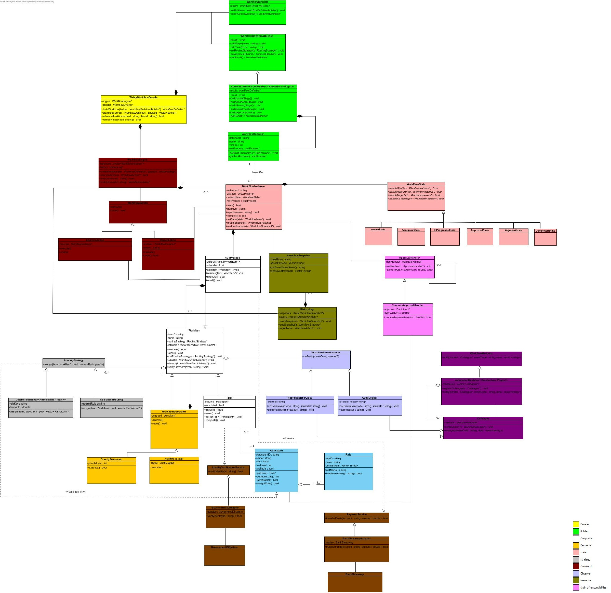
TASK 3 ACTIVITY DIAGRAMS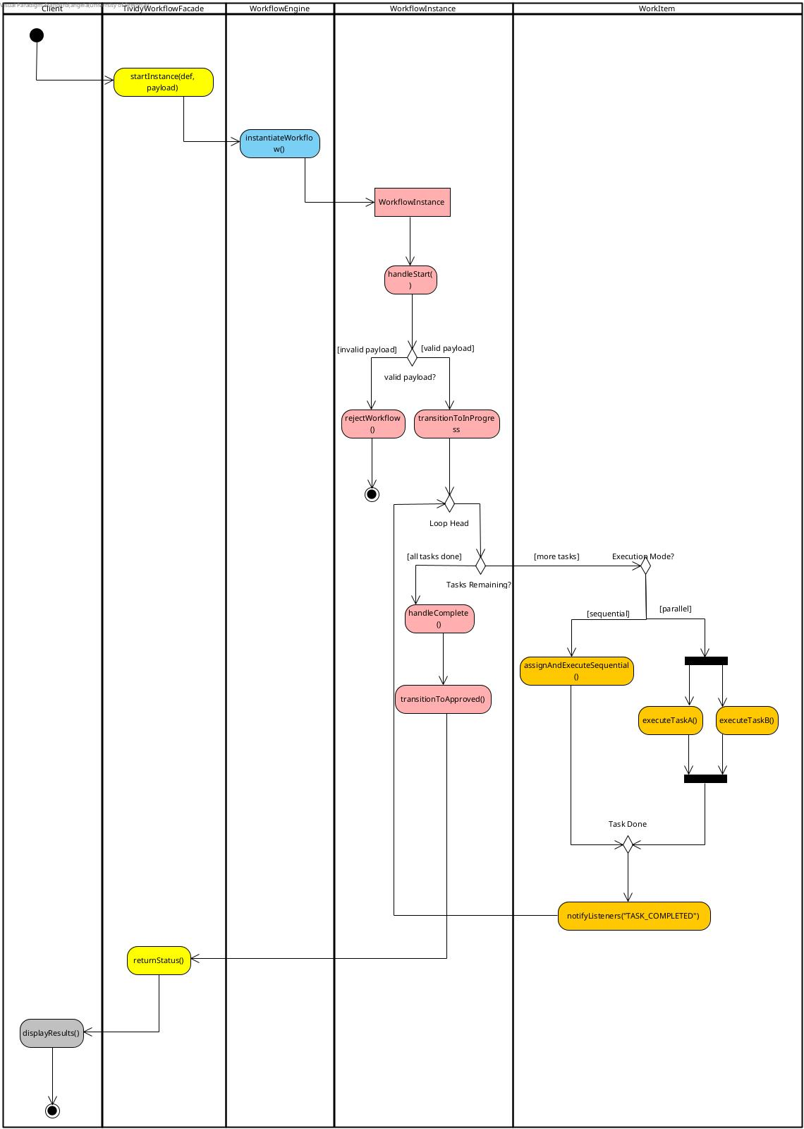
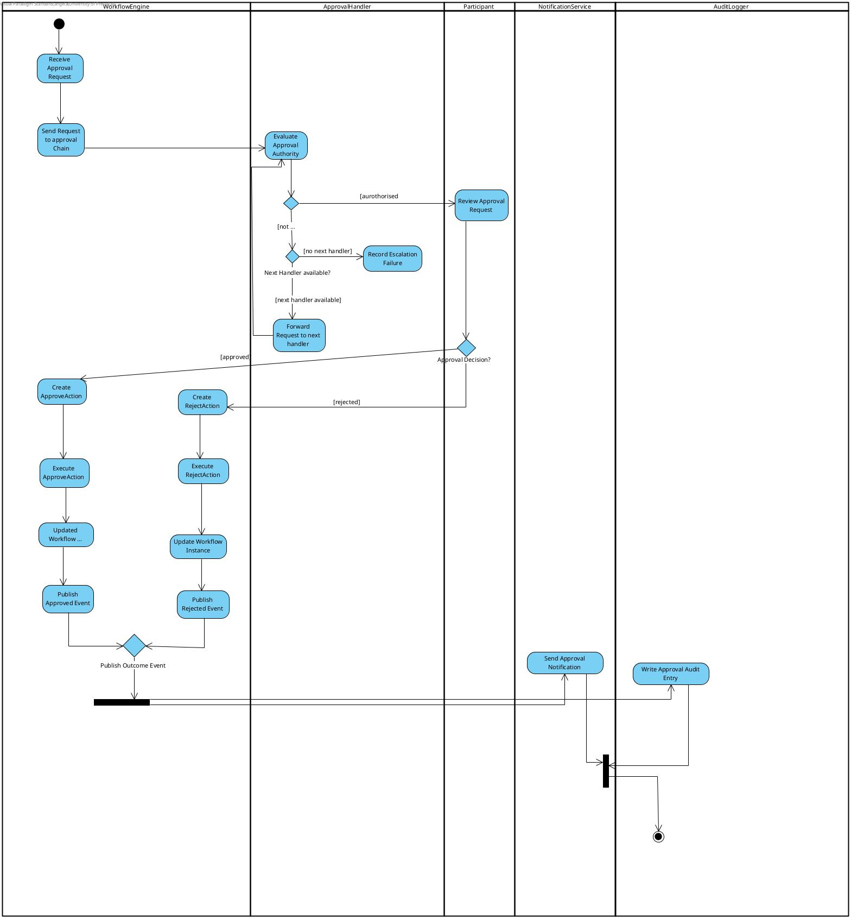
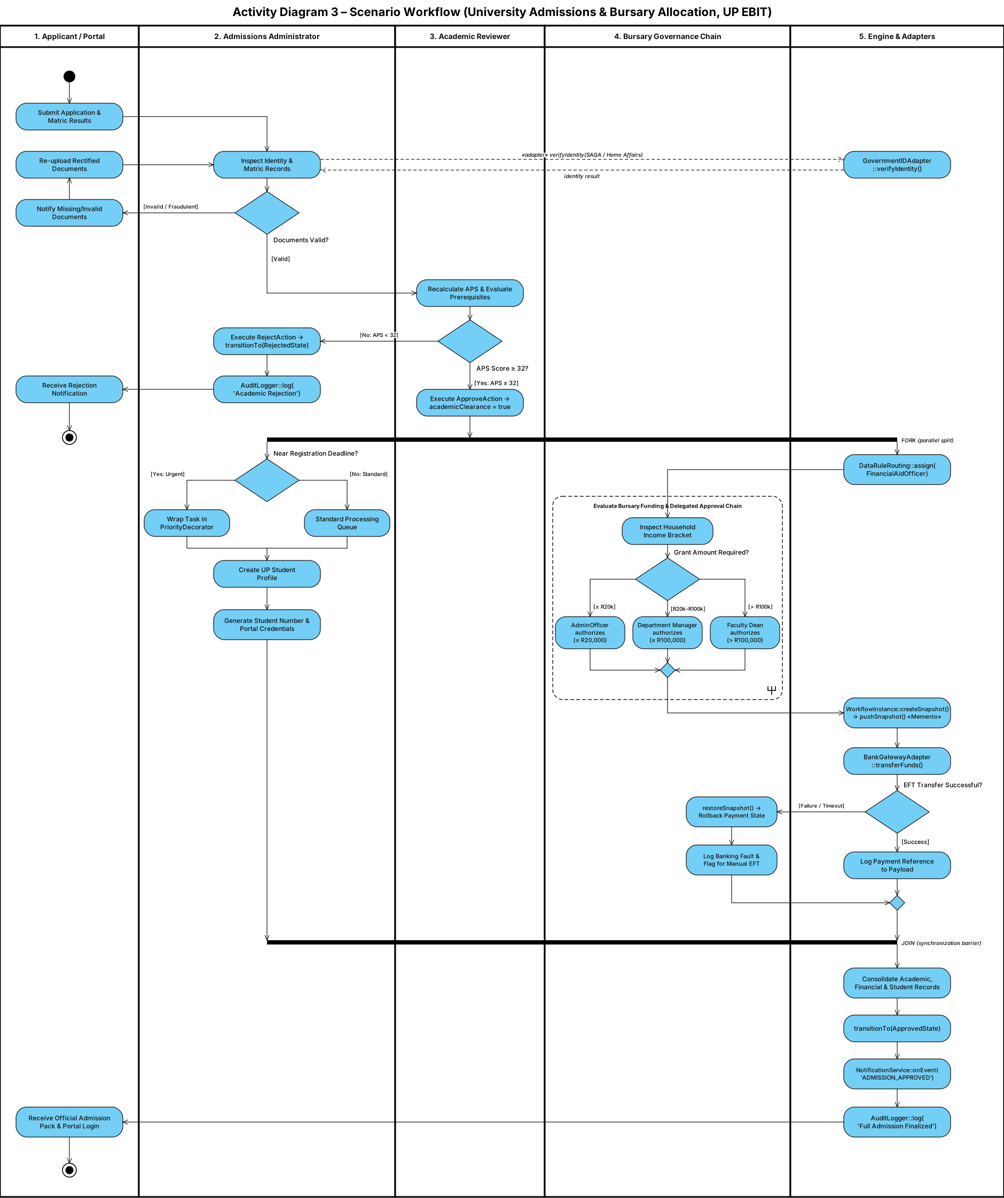

Task 4: Design Patterns
TIVIDY is designed as a generic workflow manager. The patterns below solve problems of the engine itself. The University Admissions and Bursary Processing scenario is used only to show each problem concretely and to name the classes that configure the engine; the engine’s classes are generic, and the scenario appears only in the examples and in AdmissionsWorkflowBuilder (which supplies the scenario’s configuration), AdmissionsMediator and the external-system adapters (all plug-ins that implement generic extension points). Twelve patterns are proposed (the minimum is ten). Reference numbers refer to the list under Task 1; [6] is the GoF catalogue.
# | Pattern | Category | Workflow problem it solves
1 | Builder | Creational | Definition (blueprint) must be assembled step by step and kept separate from running instances
2 | Composite | Structural | Work is nested: tasks and sub-processes must be treated uniformly
3 | State | Behavioural | Operations valid in one lifecycle state are invalid in another
4 | Strategy | Behavioural | Organisations assign work by different rules (role, workload, data)
5 | Chain of Responsibility | Behavioural | Multi-level approval and escalation by amount or timeout
6 | Command | Behavioural | Approve/reject actions must be grouped, queued and undone
7 | Memento | Behavioural | Roll back to an earlier state after a partial failure
8 | Observer | Behavioural | Several parts must react to the same completion event
9 | Decorator | Structural | Tasks gain priority or extra auditing without new task types
10 | Adapter | Structural | External systems expose interfaces not designed for TIVIDY
11 | Mediator | Behavioural | Participants communicate without knowing one another
12 | Facade | Structural | One simple entry point to the many engine subsystems

4.1 Builder (Creational)
Design problem | A workflow definition (process structure, routing rules, sub-processes and approval configuration) is complex to assemble and must exist as a reusable blueprint before any applicant is running, so that many instances can be created from it independently [1][5]. Hard-coding the admissions process inside the engine would tie TIVIDY to one scenario.
GoF participants → TIVIDY classes | Director: WorkflowDirector  Builder: WorkflowDefinitionBuilder (generic construction contract)  ConcreteBuilder: AdmissionsWorkflowBuilder (university-specific steps)  Product: WorkflowDefinition
Collaboration | WorkflowDirector calls the construction steps in order through the abstract WorkflowDefinitionBuilder. AdmissionsWorkflowBuilder supplies the admissions steps: it assembles the root SubProcess with its Tasks and nested sub-processes, sets a RoutingStrategy on each work item and configures the approval handlers, then returns the finished WorkflowDefinition.  When an application arrives, WorkflowEngine creates a WorkflowInstance from this definition. Each instance receives its own payload, state and root process tree, so a change to one applicant’s instance does not change the definition or any other instance.
What varies | Which process is being built. A new organisation or process adds a new ConcreteBuilder; the Director, engine and product stay unchanged.
Why this pattern | Only the concrete builder knows admissions-specific steps; the engine sees only the generic builder contract, so the scenario does not decide the architecture. Building step by step also keeps the definition (a blueprint) separate from the running instance, which the research identified as central [1][5].

4.2 Composite (Structural)
Design problem | Work is not flat. A process contains tasks, groups of work and nested sub-processes, some sequential and some parallel [1][2][4]. The engine must start and track one task or a whole bursary branch in the same way, without knowing how children are stored.
GoF participants → TIVIDY classes | Component: WorkItem  Leaf: Task  Composite: SubProcess (contains child WorkItems)
Collaboration | WorkflowInstance owns a root SubProcess containing Tasks (such as verify documents and academic review) and nested SubProcesses (intake, enrolment administration, bursary assessment). Executing a SubProcess executes its children, sequentially or in parallel as configured, and it finishes when its required children finish. Children are owned by composition and are destroyed with their parent.
What varies | The shape and depth of the process. New kinds of work are new WorkItem subclasses with no change to the engine.
Why this pattern | The brief asks for work and groups of work to be represented, owned and navigated without exposing storage. Hierarchical sub-processes are standard in the WfMC model and in BPMN [1][4]. Composite also removes any “is this a sub-process?” type checks.

4.3 State (Behavioural)
Design problem | A running application changes over time and operations valid at one point are invalid at another: a rejected application cannot be started. Encoding this as a status flag with if/else chains is forbidden by the project rules, and the WfMC describes process instances as state machines [1].
GoF participants → TIVIDY classes | Context: WorkflowInstance  State: WorkflowState  ConcreteStates: CreatedState, AssignedState, InProgressState, ApprovedState, RejectedState, CompletedState
Collaboration | WorkflowInstance delegates every state-dependent request to its current WorkflowState. The state either allows the transition and sets the next state, or refuses it. Example: when ApproveAction asks the instance to approve, InProgressState moves it to ApprovedState; start() on RejectedState is refused; when all branches finish the instance reaches CompletedState.
What varies | The lifecycle rules: which operations are legal in which state and what each transition triggers. A new state is a new class.
Why this pattern | Behaviour differs sharply per state, so each state’s rules live in one class instead of in conditionals inside WorkflowInstance. The transitions must match the State Diagram (Task 6).

4.4 Strategy (Behavioural)
Design problem | Different organisations, and different parts of one organisation, assign work differently: by role, by workload or availability, or by a rule over workflow data [3]. In admissions, ordinary work goes to an available administrator while bursary work depends on applicant income data. The task classes must not change when the rule does.
GoF participants → TIVIDY classes | Context: WorkItem (assignment is used by Task)  Strategy: RoutingStrategy (assign())  ConcreteStrategies: RoleBasedRouting, DataRuleRouting
Collaboration | When a Task becomes available it delegates assignment to its RoutingStrategy, which searches the Participant pool and returns an eligible one. RoleBasedRouting picks an available Participant holding a required Role (for example Admissions Administrator or Academic Reviewer); DataRuleRouting inspects the workflow payload (for example income data) to choose a financial-aid Participant.
What varies | The allocation algorithm, per work item and per organisation.
Why this pattern | The resource-patterns catalogue treats allocation rules (role-based, round-robin, shortest queue and others) as interchangeable choices [3]. Strategy keeps them out of Task and avoids a switch on allocation type.

4.5 Chain of Responsibility (Behavioural)
Design problem | Approval may involve one person or several levels, with escalation when a request is beyond someone’s authority [3][4]. In admissions, a bursary of R85,000 may exceed what the first approver can authorise. The code that asks for approval must not know who will decide.
GoF participants → TIVIDY classes | Handler: ApprovalHandler (nextHandler)  ConcreteHandler: ConcreteApprovalHandler (configured with an approver Participant and an approvalLimit)
Collaboration | The workflow sends the amount to the first ApprovalHandler. A ConcreteApprovalHandler approves if the amount is within its approvalLimit; otherwise it forwards the request to nextHandler. The titles Financial Aid Officer, Manager and Dean are Role data on the approver Participants, not separate core classes. The result goes back to the workflow, which continues or rejects.
What varies | The number of levels, their limits and their order. Changing the hierarchy means reconfiguring handler instances, not editing the engine.
Why this pattern | Hierarchical escalation is naturally a chain, and a single configurable concrete class keeps the engine generic.

4.6 Command (Behavioural)
Design problem | A reviewer’s decision (approve or reject) should not be coded directly into the portal or a task. It should be an object that can be executed uniformly, logged and potentially undone [1].
GoF participants → TIVIDY classes | Invoker: WorkflowEngine (executeAction())  Command: WorkflowAction  ConcreteCommands: ApproveAction, RejectAction  Receiver: WorkflowInstance  Client: TividyWorkflowFacade (creates the action for the reviewer’s request)
Collaboration | When the reviewer decides, the matching action is created and passed to WorkflowEngine.executeAction(). The engine runs it, and the action calls the approval or rejection transition on the WorkflowInstance, which delegates to its current WorkflowState (pattern 3). The engine can keep executed actions as history.
What varies | Which actions exist and how they are queued, logged or undone.
Why this pattern | Requests become objects, so the engine depends only on WorkflowAction and not on a switch over decision types. Adding a new decision is a new subclass.

4.7 Memento (Behavioural)
Design problem | Before an external bursary payment is attempted, the workflow needs a recovery point. If the bank call fails, the instance must return to its earlier state without exposing its internals [1].
GoF participants → TIVIDY classes | Originator: WorkflowInstance (creates and restores snapshots)  Memento: WorkflowSnapshot (state and payload; opaque to others)  Caretaker: HistoryLog
Collaboration | Before the payment step, WorkflowInstance creates a WorkflowSnapshot and HistoryLog stores it. If the external call fails, HistoryLog supplies the snapshot and the instance calls restoreSnapshot(). HistoryLog never reads inside the snapshot.
What varies | What is saved, when checkpoints are taken and how many are kept.
Why this pattern | Rollback needs the full earlier state while the instance keeps its data encapsulated. The stored snapshots also give the system a history it can use to explain what happened.

4.8 Observer (Behavioural)
Design problem | When a work item completes, several independent parts must react: the applicant must be informed and the action audited. The work item must not know how email or audit storage work [1].
GoF participants → TIVIDY classes | Subject: WorkItem  Observer: WorkflowEventListener  ConcreteObservers: NotificationService, AuditLogger
Collaboration | Listeners are attached to a WorkItem. When it completes it publishes an event to all of them: NotificationService sends the applicant a status message and AuditLogger records the action. The same mechanism produces the final outcome notification when the workflow completes.
What varies | The set of interested parties. A new reaction is a new listener with no change to WorkItem.
Why this pattern | One event needs one-to-many notification. Direct calls would couple every work item to every reaction.

4.9 Decorator (Structural)
Design problem | A bursary payment may need special auditing, or a late application may need urgent handling. A task may gain priority handling or auditing without becoming a different kind of task.
GoF participants → TIVIDY classes | Component: WorkItem  Decorator: WorkItemDecorator (wraps a WorkItem)  ConcreteDecorators: PriorityDecorator, AuditDecorator
Collaboration | The engine wraps the relevant work item, for example an AuditDecorator around the payment task. The decorator delegates to the wrapped WorkItem and adds its own behaviour (extra audit records, or priority handling). Because decorators share the WorkItem interface, they can wrap any Task or SubProcess in the tree.
What varies | Which extra behaviours apply and in what combination, chosen per instance at run time.
Why this pattern | Subclasses for every combination (such as an urgent audited bursary payment task) would multiply classes. Decorator adds behaviour per object and leaves the base task unchanged.

4.10 Adapter (Structural)
Design problem | TIVIDY must verify an applicant’s identity with a government system and pay a bursary through a bank gateway. Neither external interface was designed for TIVIDY, and the WfMC model keeps the engine independent of specific applications through agents and gateways [1].
GoF participants → TIVIDY classes | Target: IdentityVerificationService; PaymentService  Adapter: GovernmentIDAdapter; BankGatewayAdapter  Adaptee: GovernmentIDSystem; BankGateway  Client: Task (the verification and payment tasks)
Collaboration | A task calls the generic IdentityVerificationService or PaymentService. The adapter implements that interface and translates the call into the external system’s own API, then converts the result back. A successful payment stores its reference in the instance payload; a failure triggers the snapshot restore (pattern 7).
What varies | The external systems and their APIs. Replacing the bank means writing a new adapter only.
Why this pattern | The external interfaces cannot be changed, and the engine should depend only on generic service interfaces. Adapter supplies that translation layer.

4.11 Mediator (Behavioural)
Design problem | Some components must coordinate without referencing one another directly. For example, academic clearance must make the enrolment and bursary activities available, and without a mediator every component would need references to every other.
GoF participants → TIVIDY classes | Mediator: WorkflowMediator (generic communication contract)  ConcreteMediator: AdmissionsMediator  Colleague: Colleague (base class for components registered with the mediator)
Collaboration | Colleagues register with the mediator and send it notifications instead of calling each other. AdmissionsMediator decides who must react: when an academic-clearance event arrives, it makes the enrolment and bursary activities available. Cross-component communication is centralised in the mediator.
What varies | Which components take part and how they are coordinated. A new scenario supplies its own ConcreteMediator.
Why this pattern | Observer broadcasts events to listeners that do not talk back; Mediator coordinates two-way interaction among peers. Keeping the coordination rules in one scenario-specific class keeps the colleagues generic.

4.12 Facade (Structural)
Design problem | TIVIDY has many collaborating parts (builders, engine, instances, services). A client such as the applicant portal should not construct workflow objects itself or know the order of calls.
GoF participants → TIVIDY classes | Facade: TividyWorkflowFacade  Subsystem classes: WorkflowEngine, WorkflowDirector
Collaboration | The portal calls one operation, for example startInstance(definition, payload). The facade forwards the request to WorkflowEngine, which creates the WorkflowInstance from the WorkflowDefinition and starts it. The portal never touches the internal classes.
What varies | The subsystems behind the facade. Only the small facade interface needs to stay stable.
Why this pattern | The brief describes a system of many independent responsibilities; Facade gives them a single entry point and keeps clients decoupled from internal structure.

4.13 How the patterns form one system
The patterns tell one story, shown with the applicant Lindiwe. At design time WorkflowDirector and AdmissionsWorkflowBuilder (Builder) produce a WorkflowDefinition whose WorkItem tree (Composite) already has a RoutingStrategy per item (Strategy) and configured ConcreteApprovalHandlers (Chain of Responsibility). At run time the portal calls TividyWorkflowFacade (Facade), and WorkflowEngine creates Lindiwe’s WorkflowInstance in CreatedState (State). Reviewer decisions arrive as ApproveAction or RejectAction executed by the engine (Command). Completing a work item notifies NotificationService and AuditLogger (Observer), while AdmissionsMediator coordinates the parallel enrolment and bursary branches (Mediator). Before payment, WorkflowInstance saves a WorkflowSnapshot in HistoryLog (Memento), the payment and identity checks go through BankGatewayAdapter and GovernmentIDAdapter (Adapter), and any critical task can be wrapped in AuditDecorator or PriorityDecorator (Decorator). A class may take part in several collaborations: WorkItem is the Component of Composite and Decorator, the Subject of Observer and the Context of Strategy, and WorkflowInstance is the Context of State, the Originator of Memento and the Receiver of Command. These roles will be shown with colours and a legend in the UML Class Diagram (Task 5).

TASK 6 STATE DIAGRAM
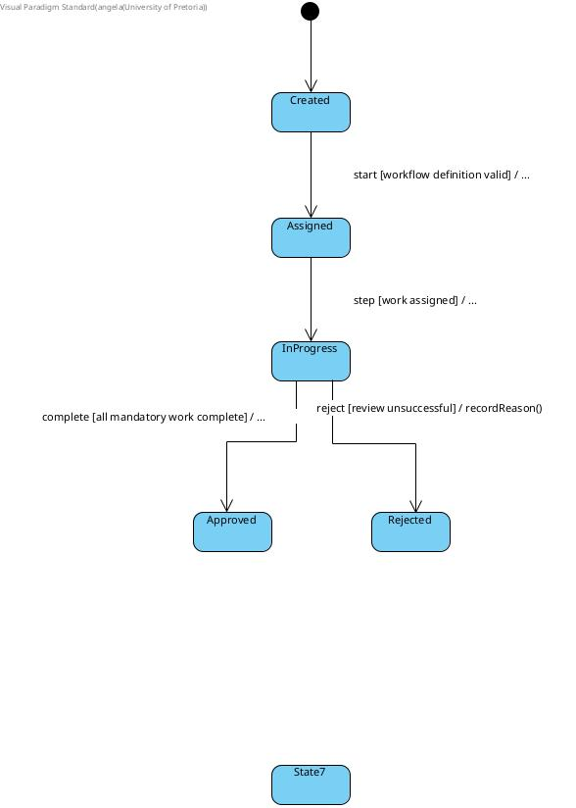
SEQUENCE DIAGRAMS
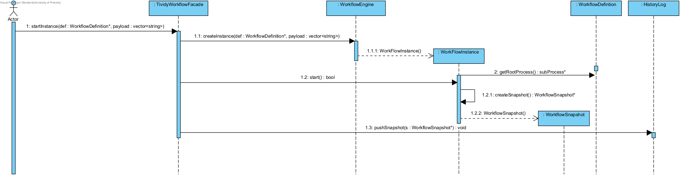

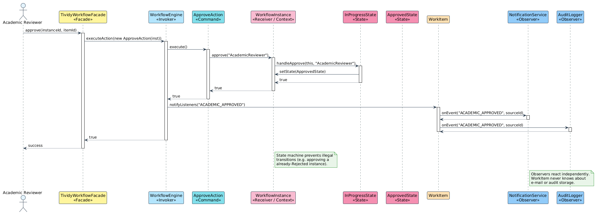

GitHub Repository Link

https://github.com/patrickkaleo/COS214_P6

Short Team Contribution Statement

Katlego Sentsho u24876489

Worked on activity diagram 2 and the state diagram.

Patrick Simuyemba u25632354

Worked on sequence diagrams 1 and 2. Github repository creation.

Enock Nyamweya u25619871

Worked on Activity Diagram 1 and came up with the branching strategy.

Angelo Anthony u25573552

Worked on Activity DIagram 3.

Ntando Dlamini u25591267

Worked on the class Diagram and Task 2.

Angela Ramaboea u25445392

Worked on task 1 and task 4 and overall compilation of the submission document.

